Descriptive Analysis SRAG database

**NAs**

1. Database for 2009 to 2012

Over the years of 2009 to 2011, on average 74% of individuals in the database didn’t do the PCR test to identify the type of Influenza (variable PCR_ETIOL).

Good news: the % of NAs kept constant over these years

Checking if there is any pattern of NA’s across cohorts.

Variable (**PCR_ETIOL**)

Figure 1- Cohort effects H1N1 - Cases

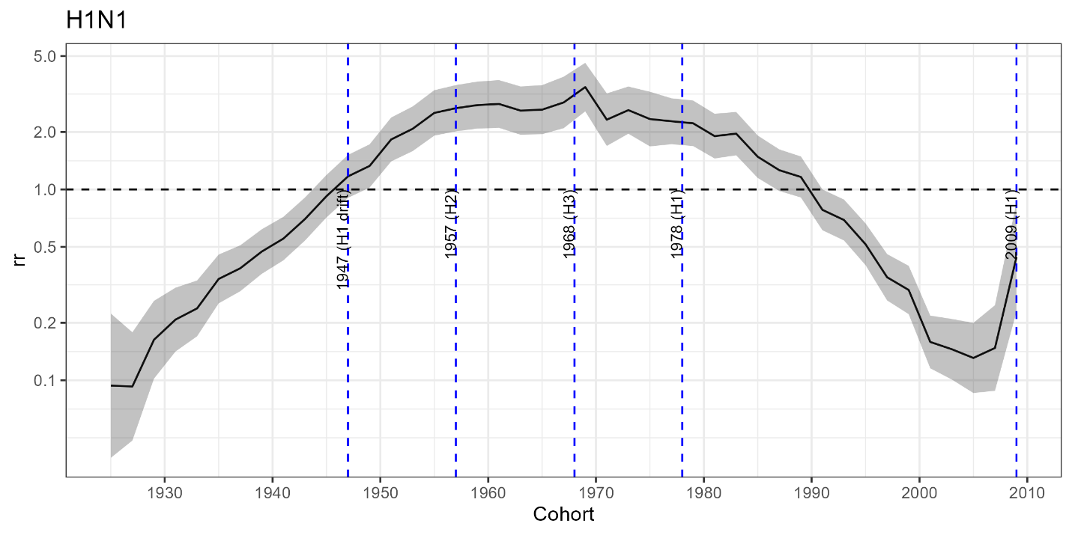

Figure 2-

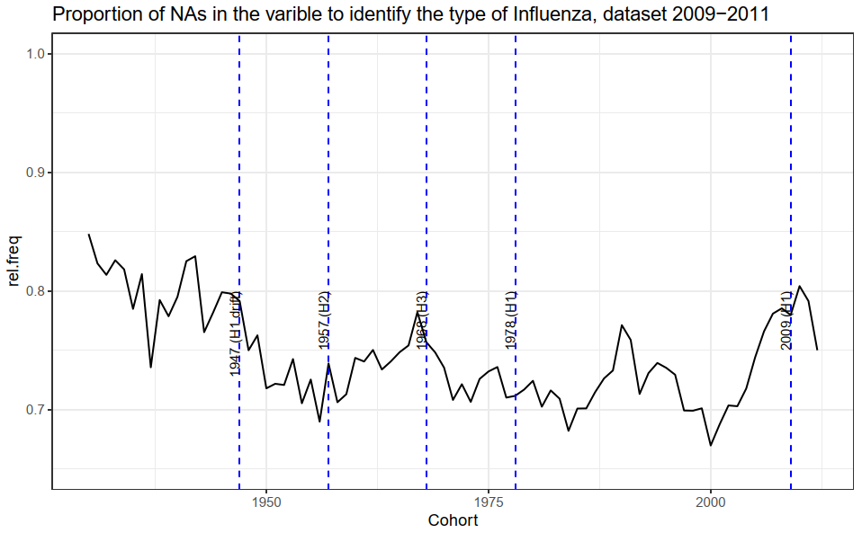

By comparing Figs 1 and 2, it is interesting to see that the number of cases follow a similar trend of the proportion of reporting cases. For instance, the increased in rr between the birth cohorts of 1947 and 1957 can be partially explained by the reduction of about 7% of NAs

1. Database for 2012 to 2018 (pending to adjust 2012)

Variable (**RES_FLUASU**)

Compared with the database 2009-2011, the proportion of NAs increased

Figure 1- Cohort effects H1N1 - Cases

Figure 3-

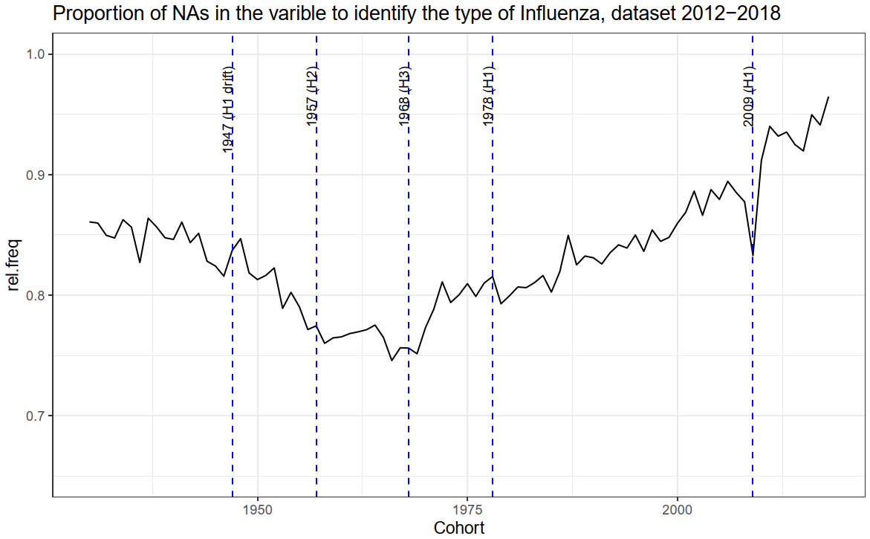

Issue: in 2012 98.7% of the variable RES_FLUASU (variable to identify the type of Influenza) is NA.

1. Database for 2019

Variable (TP_FLU_PCR): to identify the flu type

Figure 3-

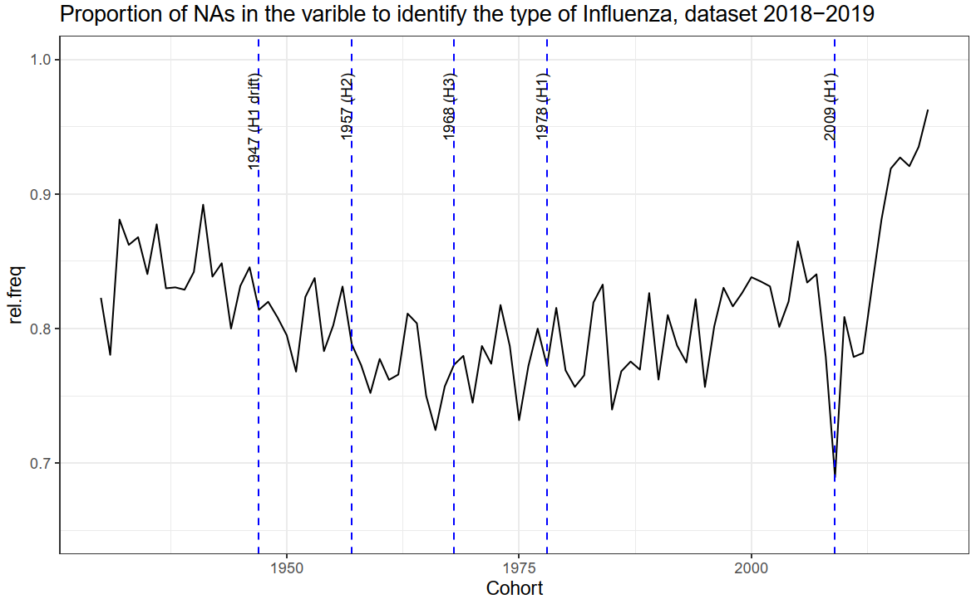

**Including other tests to identify the type of Influenza**

The inclusion of other tests to detect the type and subtype of influenza virtually did not change the

number of cases

In my opinion, doesn't worth to include them. Moreover, in the dataset of 2019 it is not possible to identify the subtype from the IF tests.